15.Write a Pandas program to keep the rows with at least 2 NaN values in a given
DataFrame.

Aim:
To write a Pandas program to keep the rows with at least 2 NaN values in a given DataFrame.
Program:
import pandas as pd
import numpy as np

data = pd.DataFrame({
"A": [1, np.nan, np.nan, 4, np.nan],
"B": [2, np.nan, 3, np.nan, np.nan],
"C": [np.nan, 5, np.nan, 6, 7],
"D": [4, np.nan, 8, 9, np.nan]
})

result = data[data.isnull().sum(axis=1) >= 2]

print(result)
Output:
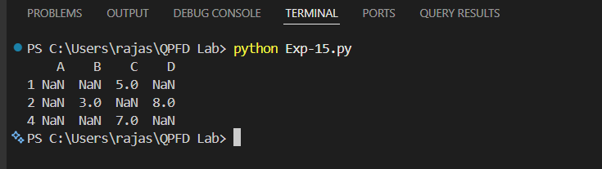
Result:
The program successfully displayed the rows containing at least 2 NaN (missing) values.

16.Write a Pandas program to split the following dataframe into groups based on school
code. Also check the type of GroupBy object.
Aim:
To write a Pandas program to split a DataFrame into groups based on school code and check the type of the GroupBy object.
Program:
import pandas as pd

data = pd.DataFrame({
"school_code": ["S001", "S002", "S001", "S003", "S002", "S001"],
"school_name": ["ABC", "XYZ", "ABC", "PQR", "XYZ", "ABC"],
"student_name": ["Ravi", "Anu", "Kiran", "Meena", "Rahul", "Divya"],
"marks": [85, 90, 78, 88, 76, 95]
})

group = data.groupby("school_code")

print(group)

print(type(group))

for code, details in group:
print("\nSchool Code:", code)
print(details)

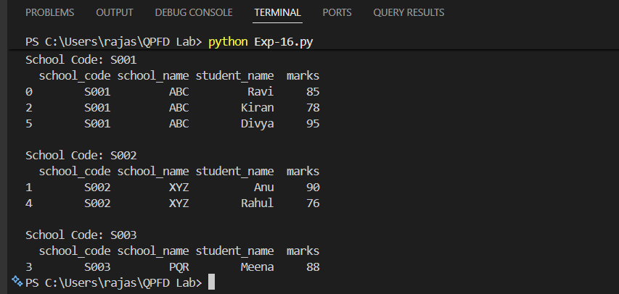
Output:

Result:
The program successfully split the DataFrame into groups based on school_code and displayed the type of the GroupBy object.

